

**MINISTERUL EDUCAȚIEI, CULTURII ȘI CERCETĂRII**

**AL REPUBLICII MOLDOVA**

**Universitatea Tehnică a Moldovei**

**Facultatea Calculatoare, Informatică şi Microelectronică**

**Departamentul Informatică şi Ingineria Sistemelor**

**Calancea Catalin**

**MI-222**

**Raport**

**pentru lucrarea de laborator Nr.3**

***la cursul de “Programare Procedurala”***

Verificat:

lector universitar

Braniste Rodica

**Chișinău – 20****22**

**1.Scopul lucrării de laborator :**

Sarcina acestei lucrări de laborator este crearea unei aplicații ce va rula în Excel și va folosi un șir de funcții definite de programator destinate prelucrării vectorilor în Excel. Va fi creată o aplicație care calculează suma elementelor unui vector, suma a 2 vectori, va afla elementul minim și maxim al vectorului, va scalariza un vector și va sorta un vector. Toate aceste acțiuni vor fi îndeplinite cu ajutorul funcțiilor definite de către programator.

**2.Conditia/conditiile problemelor:**

1. Elaboraţi forma propusă în lucrare.

2. Comentaţi detaliat codurile associate obiectelor formei propuse

3. Modificaţi forma şi codul respectiv pentru adăugarea cel puţin a doua obiecte/evenimente.

4. Faceţi concluzii

5. Prezentaţi lucrarea profesorului.

**3. Codul programului:**

Public Function SumaVector() As Double

Dim i As Integer

Dim n As Integer

Dim Suma As Double

Dim m As Range

Set m = Worksheets("Project").Range(ActiveWindow.RangeSelection.Address)

n = m.Rows.Count

ReDim vect(1 To n) As Double

Suma = 0

For i = 1 To n

vect(i) = m(i)

Suma = Suma + vect(i)

Next i

SumaVector = Suma

End Function

Public Function MaxVector() As Double

Dim i As Integer

Dim m As Range

Dim n As Integer

Dim max As Double

Set m = Worksheets("Project").Range(ActiveWindow.RangeSelection.Address)

n = m.Rows.Count

ReDim vect(1 To n) As Double

For i = 1 To n: vect(i) = m(i): Next i

max = vect(1)

For i = 2 To n

If (vect(i) > max) Then

max = vect(i)

End If

Next i

MaxVector = max

End Function

Public Function MinVector() As Double

Dim i As Integer

Dim n As Integer

Dim min As Double

Dim m As Range

Set m = Worksheets("Project").Range(ActiveWindow.RangeSelection.Address)

n = m.Rows.Count

ReDim vect(1 To n) As Double

For i = 1 To n: vect(i) = m(i): Next i

min = vect(1)

For i = 2 To n

If (vect(i) < min) Then

min = vect(i)

End If

Next i

MinVector = min

End Function

Public Function ScaleVector(sc As Double) As Double()

Dim i As Integer

Dim n As Integer

Dim m As Range

Set m = Worksheets("Project").Range(ActiveWindow.RangeSelection.Address)

n = m.Rows.Count

ReDim vect(1 To n) As Double

For i = 1 To n: vect(i) = m(i): Next i

ReDim scaled(1 To n) As Double

For i = 1 To n

scaled(i) = sc * vect(i)

Next i

ScaleVector = scaled

End Function

Public Function Suma2Vec(rng1 As Range, rng2 As Range) As Variant

Dim i As Integer

Dim n1 As Integer

Dim n2 As Integer

n1 = rng1.Rows.Count

n2 = rng2.Rows.Count

If (n1 <> n2) Then

Suma2Vec = "Dimensiuni inegale."

Exit Function

End If

ReDim vect(1 To n1) As Double

For i = 1 To n1

vect(i) = rng1(i) + rng2(i)

Next i

Suma2Vec = vect

End Function

Public Function Bubble(rng As Range) As Double()

Dim temp As Double

Dim i As Integer, j As Integer

Dim n As Integer

n = rng.Rows.Count

ReDim A(1 To n) As Double

For i = 1 To n

A(i) = rng(i)

Next i

For i = 1 To n - 1

For j = 1 To n - i

If (A(j) > A(j + 1)) Then

temp = A(j)

A(j) = A(j + 1)

A(j + 1) = temp

End If

Next j

Next i

Bubble = A

End Function

Private Sub CommandButton1_Click()

Dim vect1 As Range

Dim vect2 As Range

Dim rez As Variant

Dim col As Integer

Set vect1 = Range(insCol9.Value)

Set vect2 = Range(insCol10.Value)

rez = Diferenta2Vec(vect1, vect2)

If (VarType(rez) = vbString) Then

MsgBox rez

Else

col = insCol11.Value

Cells(1, col).Value = "Suma 2 vectori"

For i = 1 To vect1.Rows.Count

Cells(i + 1, col).Value = rez(i)

Next i

End If

End Sub

Private Sub MultiPage1_Change()

End Sub

Private Sub UserForm_Activate()

Set vect = Worksheets("Project").Range(ActiveWindow.RangeSelection.Address)

End Sub

Private Sub cmdExit_Click()

UserForm1.Hide

Unload UserForm1

End Sub

Private Sub cmdMinMax_Click()

Dim min As Double

Dim max As Double

min = MinVector()

max = MaxVector()

viewMin.Caption = "Minimul este: " & min

viewMax.Caption = "Maximul este: " & max

End Sub

Private Sub cmdScale_Click()

Dim c As Double

Dim n As Integer

Dim col As Integer

Dim m As Range

Set m = Worksheets("Project").Range(ActiveWindow.RangeSelection.Address)

n = m.Rows.Count

c = insConst.Value

ReDim scal(1 To n) As Double

scal = ScaleVector(c)

col = insCol.Value

Cells(1, col).Value = "Scaled"

For i = 1 To n

Cells(i + 1, col).Value = scal(i)

Next i

End Sub

Private Sub cmdSort_Click()

Dim col As Integer

ReDim rez(1 To vect.Rows.Count) As Double

rez = Bubble(vect)

col = insCol4.Value

Cells(1, col).Value = "Sorted"

For i = 1 To vect.Rows.Count

Cells(i + 1, col).Value = rez(i)

Next i

End Sub

Private Sub cmdSuma_Click()

Dim sum As Double

sum = SumaVector()

viewSuma.Caption = "Suma este: " & sum

End Sub

Private Sub cmdSumeaza_Click()

Dim vect1 As Range

Dim vect2 As Range

Dim rez As Variant

Dim col As Integer

Set vect1 = Range(insCol1.Value)

Set vect2 = Range(insCol2.Value)

rez = Suma2Vec(vect1, vect2)

If (VarType(rez) = vbString) Then

MsgBox rez

Else

col = insCol3.Value

Cells(1, col).Value = "Suma 2 vectori"

For i = 1 To vect1.Rows.Count

Cells(i + 1, col).Value = rez(i)

Next i

End If

End Sub

Public Function Diferenta2Vec(rng1 As Range, rng2 As Range) As Variant

Dim i As Integer

Dim n1 As Integer

Dim n2 As Integer

n1 = rng1.Rows.Count

n2 = rng2.Rows.Count

If (n1 <> n2) Then

Diferenta2Vec = "Dimensiuni inegale."

Exit Function

End If

ReDim vect(1 To n1) As Double

For i = 1 To n1

vect(i) = rng1(i) - rng2(i)

Next i

Diferenta2Vec = vect

End Function

**Afisare:**

Mesajul inițial:

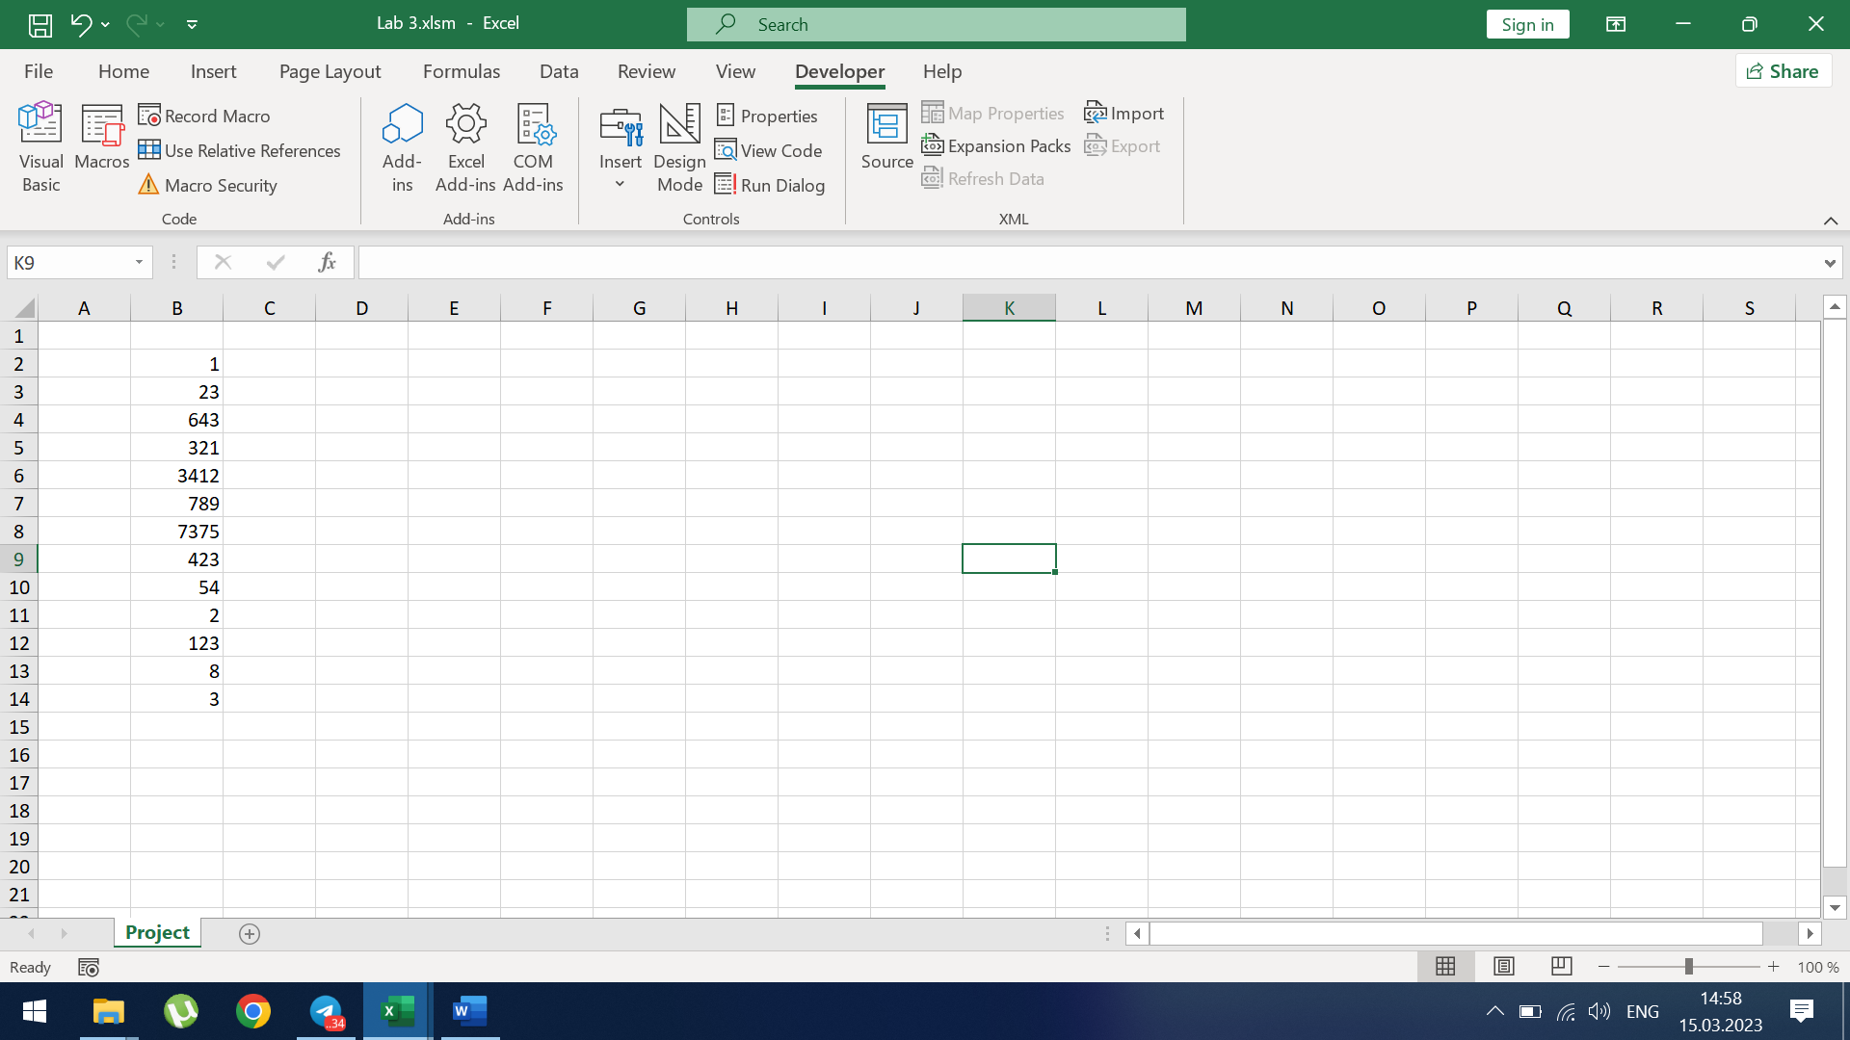

După click pe prima functie: 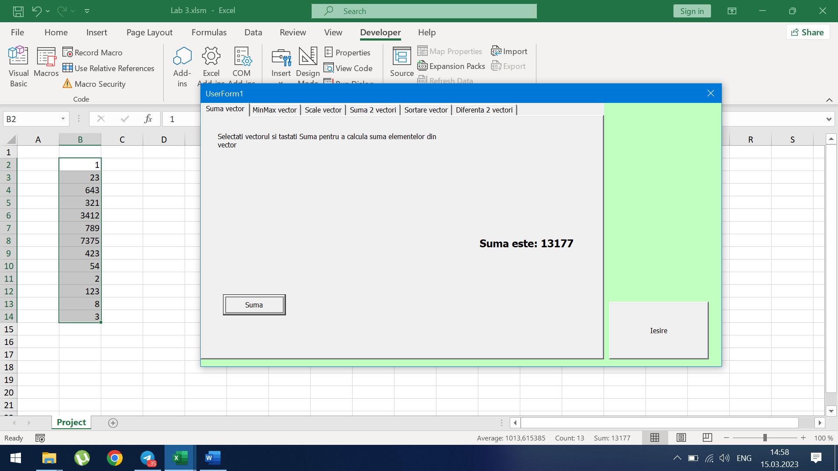

După click pe a II-a functie:

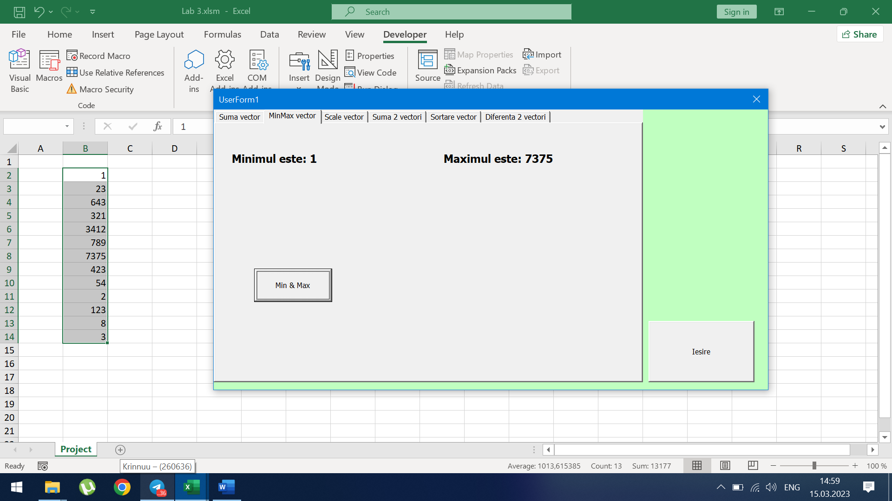

După click pe a III-a functie:

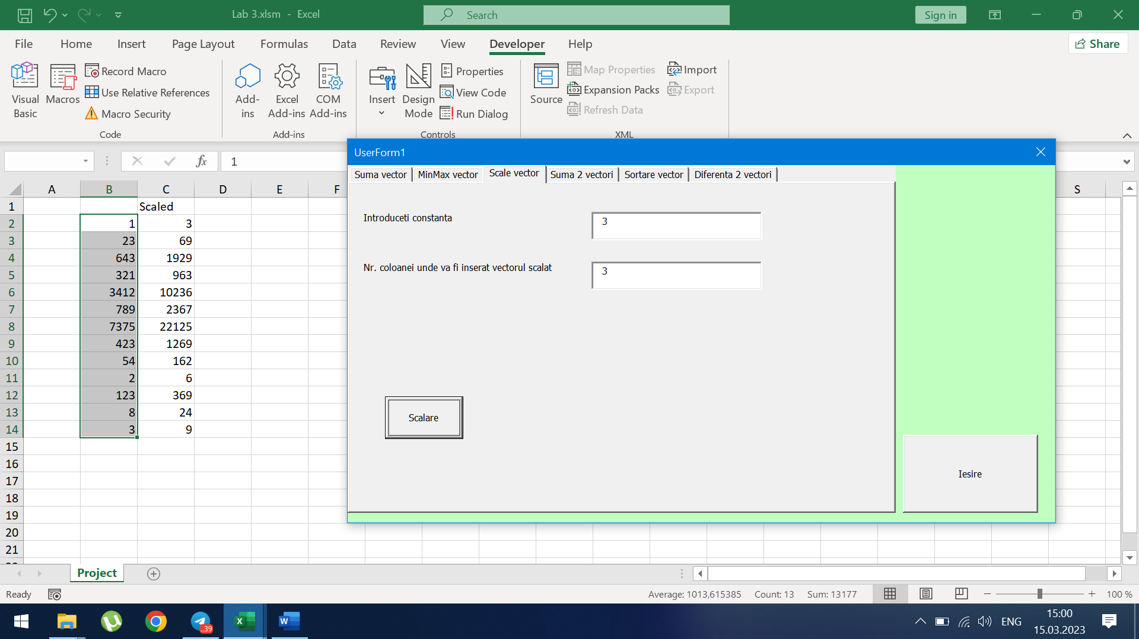

După click pe a IV-a functie:

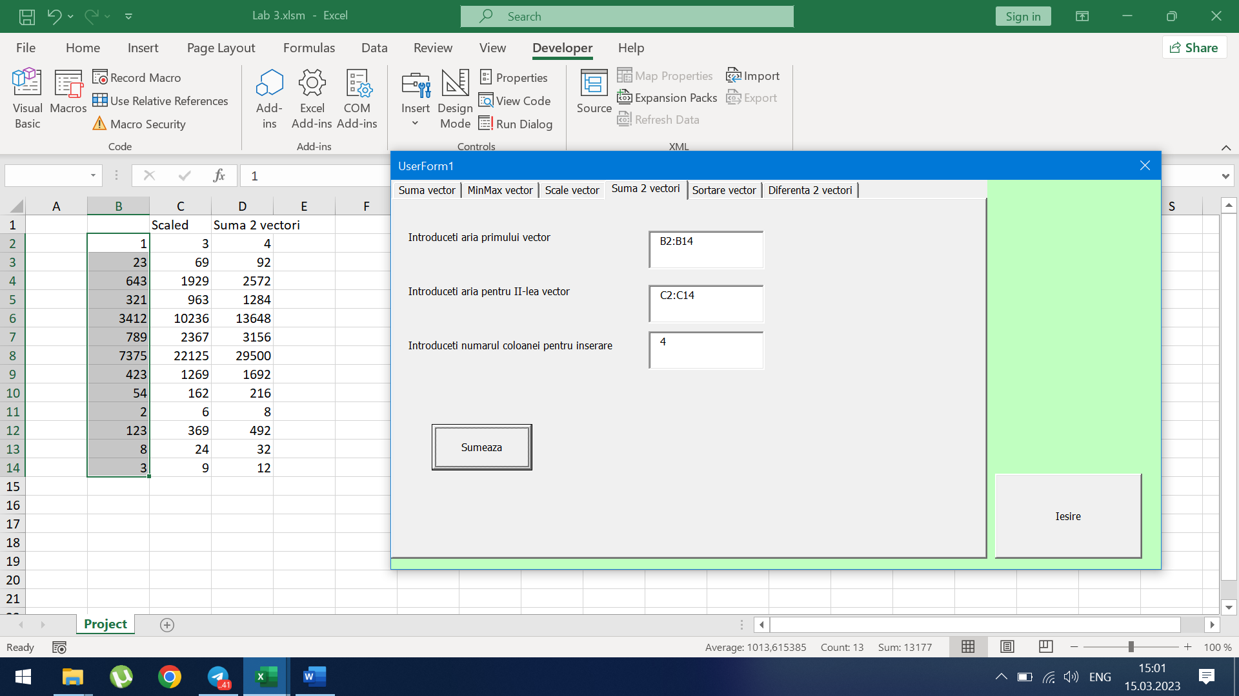

**5.Concluzie**

In aceasta lucrare am lucrat intr-o aplicatie ,cu limbaj de programare asemanator cu unul studiat mai devreme. Am avut placere sa lucrez in limbajul de programare Visual Basic for Applications (VBA) și mediul de dezvoltare pentru acest limbaj Visual Basic Editor (VBE) ,deoarece editorul are interfata disponibila de inteles intuitive ,si fara multe cunostinte in domeniu. In final pot spune ca VBA este un limbaj util pentru modelarea aplicatiilor